📊 Loan Default Risk Analysis Using Power BI
A Credit Risk Analytics Project Report

1. Introduction
Loan default risk is a major concern for financial institutions such as banks, Non-Banking Financial Companies (NBFCs), and digital lending platforms. With increasing credit demand and diverse borrower profiles, effective monitoring and assessment of credit risk have become essential to ensure financial stability and minimize losses.
This project focuses on analyzing historical loan data to understand default behavior, identify high-risk borrower segments, and evaluate overall loan portfolio exposure. Using Power BI, the project applies standard financial risk metrics to convert raw data into meaningful insights that support data-driven lending and risk management decisions.

2. Problem Statement
Financial institutions manage large volumes of loan data, making manual analysis inefficient and prone to error. Without a structured analytical system, it is difficult to track default trends, estimate potential losses, and identify risky borrowers in a timely manner.
The problem addressed in this project is the lack of a centralized, interactive dashboard that can provide a clear view of loan default risk and portfolio exposure. The project aims to solve this by developing a Power BI dashboard that visualizes key risk indicators and supports effective decision-making.

3. Objectives
The main objectives of this project are:
- To analyze loan default patterns across different borrower segments
- To identify high-risk customers based on demographic and financial attributes
- To measure credit exposure and estimate potential losses
- To apply industry-standard credit risk KPIs
- To design an interactive dashboard for risk monitoring and reporting

4. Dataset Description
The dataset used in this project contains borrower-level and loan-level information relevant to credit risk analysis. It includes attributes such as borrower demographics, loan details, and risk parameters.
Key data fields include:
- Loan ID and Customer ID
- Age group, gender, and employment type of borrowers
- Income and loan amount
- Loan status indicating defaulted or non-defaulted loans
- Risk metrics such as Exposure at Default (EAD), Probability of Default (PD), and Loss Given Default (LGD)
This dataset enables both customer-level and portfolio-level risk analysis.

5. Methodology
The project follows a systematic analytical approach:
- Data Understanding and Preparation
The dataset was reviewed for consistency and completeness. Basic data cleaning and validation were performed to ensure accurate analysis.
- Definition of Risk Metrics
Key credit risk indicators such as Default Rate, EAD, PD, LGD, and Expected Credit Loss were identified based on standard banking practices.
- DAX Measure Implementation
Custom measures were created in Power BI using DAX to calculate KPIs and risk metrics dynamically.
- Dashboard Development
Multiple report pages were designed to analyze portfolio overview, customer risk, and exposure metrics. Interactive filters and slicers were added for deeper analysis.
- Insight Generation
Visual patterns were interpreted to identify trends, risk concentrations, and high-risk segments.

6. Key Risk Metrics Used
The analysis is based on the following credit risk metrics:
- Default Rate – Percentage of loans that have defaulted
- Exposure at Default (EAD) – Total outstanding exposure at the time of default
- Probability of Default (PD) – Likelihood of a borrower defaulting
- Loss Given Default (LGD) – Proportion of loss in case of default
- Expected Credit Loss (ECL) – Estimated loss calculated using:
$$\text{Expected Loss}=EAD×PD×LGD$$
These metrics are widely used in financial risk management to assess portfolio health.

7. Dashboard Overview
The Power BI dashboard is divided into the following report pages, each designed to provide insights into different aspects of loan default risk and financial exposure.

7.1 Report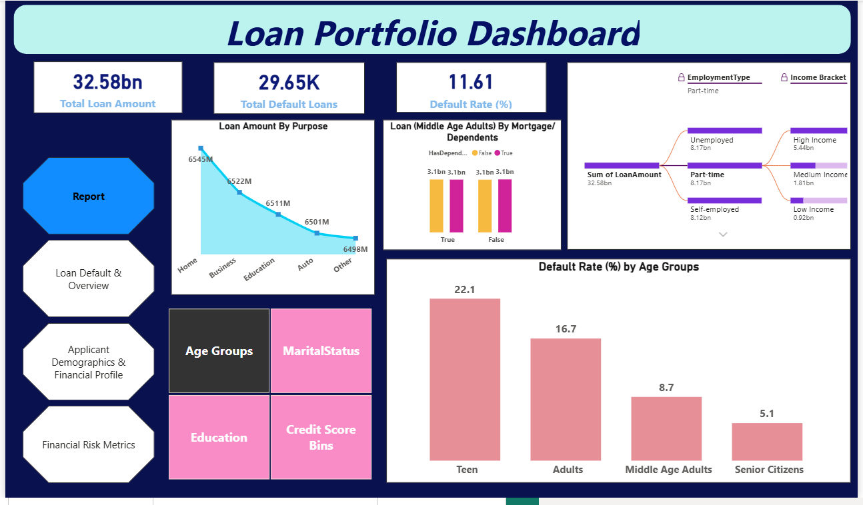
The Report page provides a high-level summary of the loan portfolio. It presents key indicators such as total loans, total defaulted loans, overall default rate, and total exposure at default (EAD). This page serves as a quick reference for understanding the overall risk position of the portfolio.

7.2 Loan Default & Overview

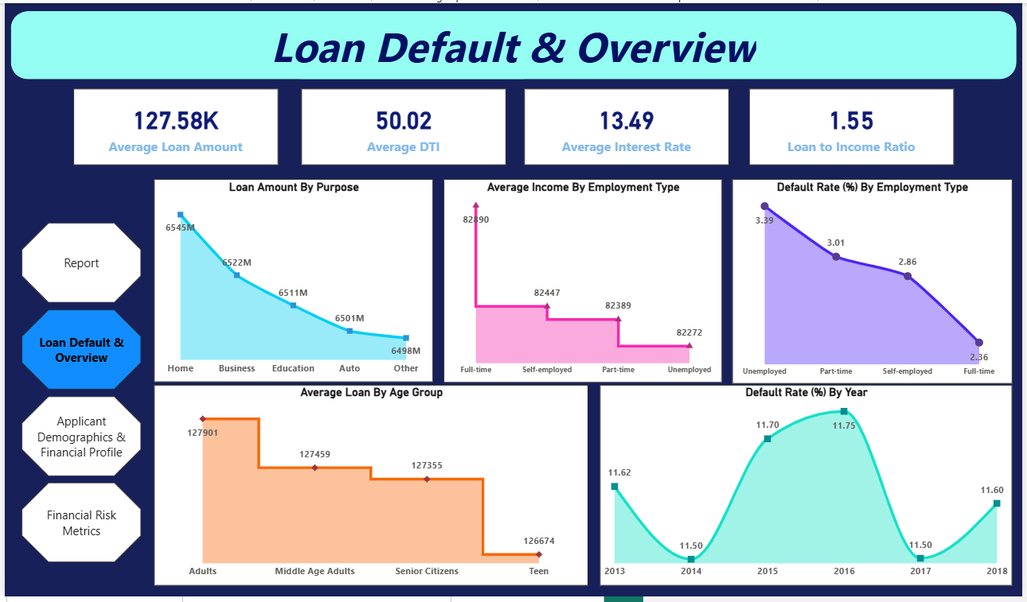
The Loan Default & Overview page focuses on analyzing loan performance and default trends. It highlights defaulted versus non-defaulted loans, default rates, and exposure distribution, enabling stakeholders to assess portfolio quality and identify areas of concern.

7.3 Applicant Demographics & Financial Profile

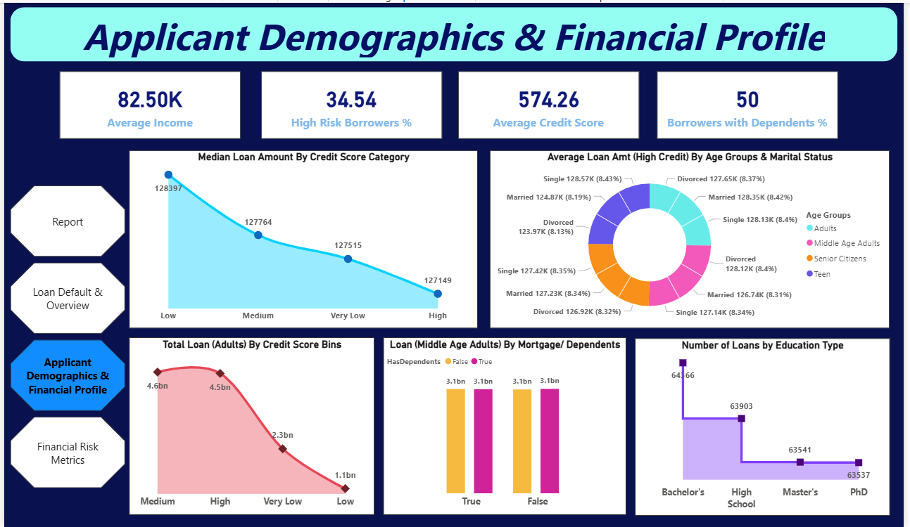
The Applicant Demographics & Financial Profile page analyzes borrower characteristics such as age group, gender, employment type, income level, and loan amount. This page helps identify high-risk customer segments and understand how demographic and financial factors influence default behavior.

7.4 Financial Risk Metrics

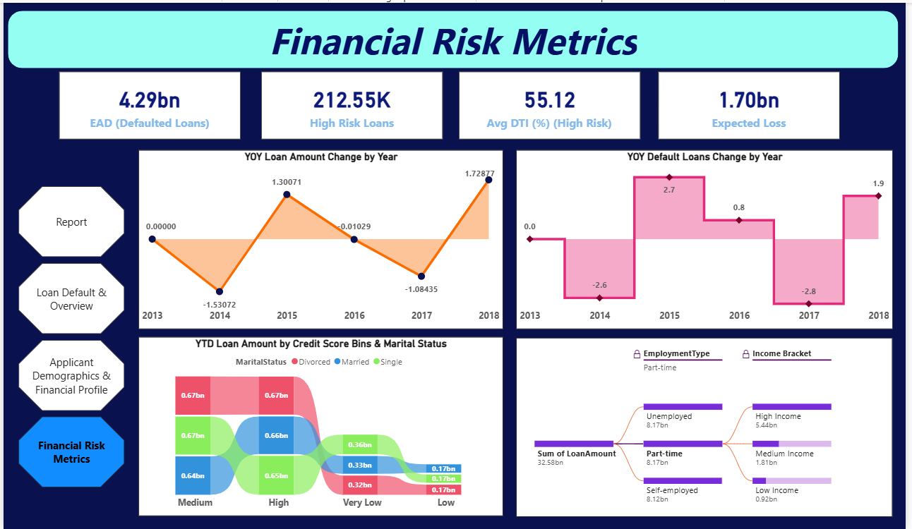
The Financial Risk Metrics page emphasizes advanced credit risk indicators. It includes metrics such as Exposure at Default (EAD), Probability of Default (PD), Loss Given Default (LGD), and Expected Credit Loss. This page is designed for in-depth risk assessment, management review, and regulatory reporting.

8. Key Insights and Findings
- Default risk varies significantly across different age groups and employment types
- Certain borrower segments contribute disproportionately to total portfolio exposure
- A relatively small set of loans accounts for a large portion of expected losses
- Portfolio risk is concentrated rather than evenly distributed
These insights highlight the importance of targeted risk management strategies.

9. Business Use Case
The developed dashboard can be used by financial institutions to:
- Monitor credit risk at both customer and portfolio levels
- Support risk-based lending and pricing decisions
- Estimate potential losses and take preventive actions
- Assist management and regulatory reporting

10. Conclusion
This project demonstrates how Power BI combined with credit risk analytics can be effectively used to analyze loan default behavior and portfolio exposure. The interactive dashboard provides valuable insights that help identify high-risk segments and estimate potential losses. Such an analytical approach can significantly improve credit risk management and support informed decision-making in financial institutions.

11. Future Enhancements
- Inclusion of time-series analysis to study default trends
- Integration of credit score and repayment history data
- Predictive modeling using machine learning techniques
- Automated data refresh using Power BI Service
- Stress testing and scenario-based risk analysis

